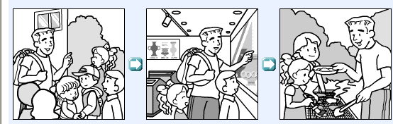
____________________________________________________________________________________________________________________________________________________________________________________________________________________________________________________________________________________
_______________________________________________________________________________________________________________________________________________________________________________________________________________
_______________________________________________________________________________________________________________________________________________________________________________________________________________
_______________________________________________________________________________________________________________________________________________________________________________________________________________
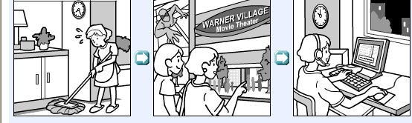

____________________________________________________________________________________________________________________________________________________________________________________________________________________________________________________________________________________
_______________________________________________________________________________________________________________________________________________________________________________________________________________
_________________________________________________________________________________________________________________________________________________________________________________________________________________________________________________________________________________________________________________________________________________________

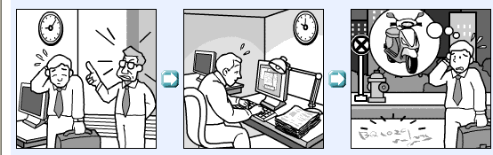

____________________________________________________________________________________________________________________________________________________________________________________________________________________________________________________________________________________
_____________________________________________________________________________________________________________________________________________________________________________________________________________________________________________________________________________________________________________________________________________________________________________________________________________________________________________________________________________________________________________________________________________________________________________________________________________________________________________

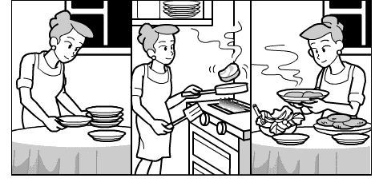

_______________________________________________________________________________________________________________________________________________________________________________________________________________________________________________________________________________________________________________________________________________________________________________________________________________________________________________________________________________________________________________________________________________________________________________________________________________________________________________________________________________________________________________________________________________________________________________________

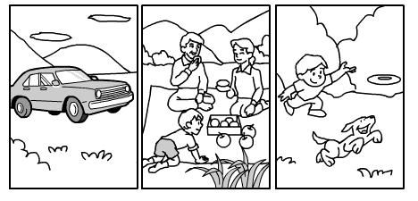

_________________________________________________________________________________________________________________________________________________________________________________________________________________________________________________________________________________________________________________________________________________________________________________________________________________________________________________________________________________________________________________________________________________________________________________________________________________________________________________________________________________________________________________
_____________________________________________________________________

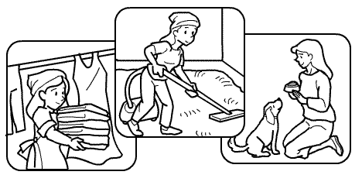
__________________________________________________________________________________________________________________________________________________________________________________________________________________________________________________________________________________________________________________________________________________________________________________________________________________________________________________________________________________________________________________________________________________________________________________________________________________________________________________________________________________________________________________________________________________________________________________________________________________________________________________________

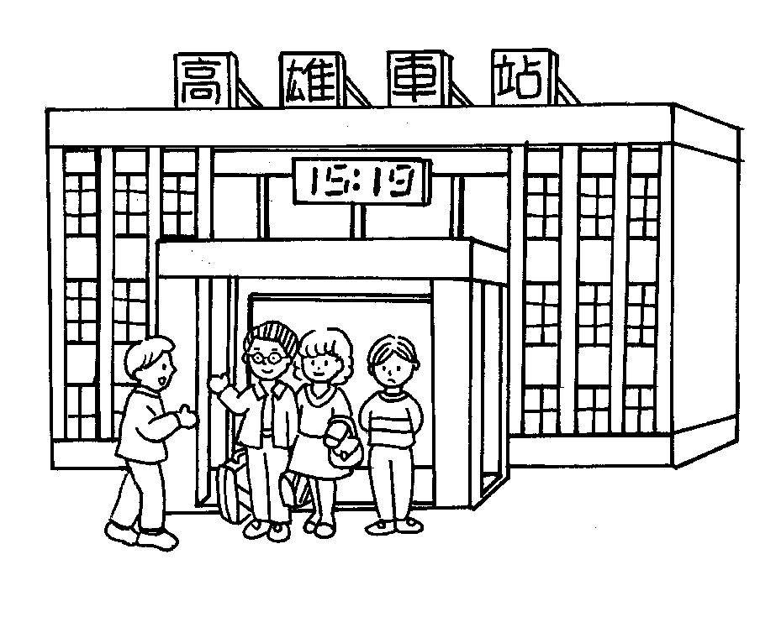  星期五 | 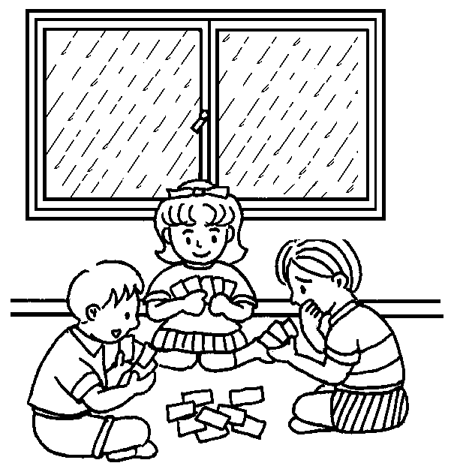  星期六 | 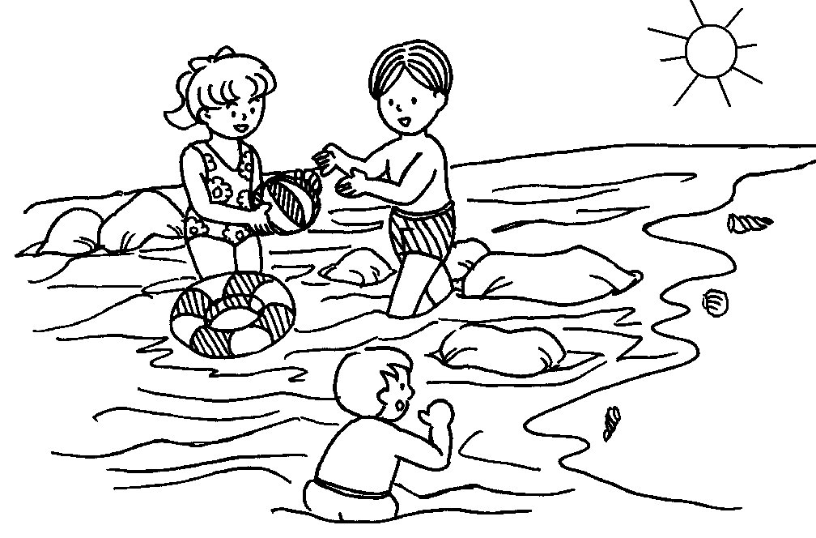  星期日

______________________________________________________________________________________________________________________________________________________________________________________________________________________________________________________________________________________________________________________________________________________________________________________________________________________________________________________________________________________________________________________________________________________________________________________________________________________________________________________________________________________________________________________________________________________________________________________________________________________________________________________________________________________________________________________________________________________________________________________________________





