Night Markets in Taiwan

Taiwan’s Night Markets


There are night markets in almost every town and city in Taiwan which attract many local people and foreign visitors. ¹Shihlin night market is one of the largest night markets in Taipei. It is well known for its ²food stalls lining the streets and the many small restaurants in its ³giant old ⁴food hall. These food stalls and restaurants sell all types of food including steak, hot dogs, and many traditional Taiwanese and Chinese meals and snacks, such as ⁵oyster omelets, ⁶coffin bread, deep-fried buns and many seafood, noodle and rice dishes. There are also lots of small shops which sell things like shoes, clothes, ⁷jewelry and ⁸furniture as well as ⁹novelty items and ¹⁰traditional products.

Another famous Taipei market is the ¹¹Huahsi Street night market. Most shops owners there wear the same ¹²uniforms and many restaurants are famous for their snake soup. Other large night markets in Taipei include ¹³Tonghwa, ¹⁴Liaoning and ¹⁵Jaoho night market.


In Kaohsiung, people can visit the ¹⁶Liuhe and ¹⁷Hsinhsing night markets. Liuhe is best known for its different types of snacks, while Hsinhsing sells mainly good-quality, inexpensive clothes for younger people.

A large night market in Taichung is the ¹⁸Chunghua night market, while in Tainan people can go to the ¹⁹Hsiaopei and the ²⁰Chungwo Cheng night markets. Both of these Tainan markets serve a number of snacks, or ²¹Hsiao chi, which are particularly famous in that city.

Important Vocabulary & Phrases

1. Shihlin night market：士林夜市 | 11. Huahsi Street night market：華西街夜市
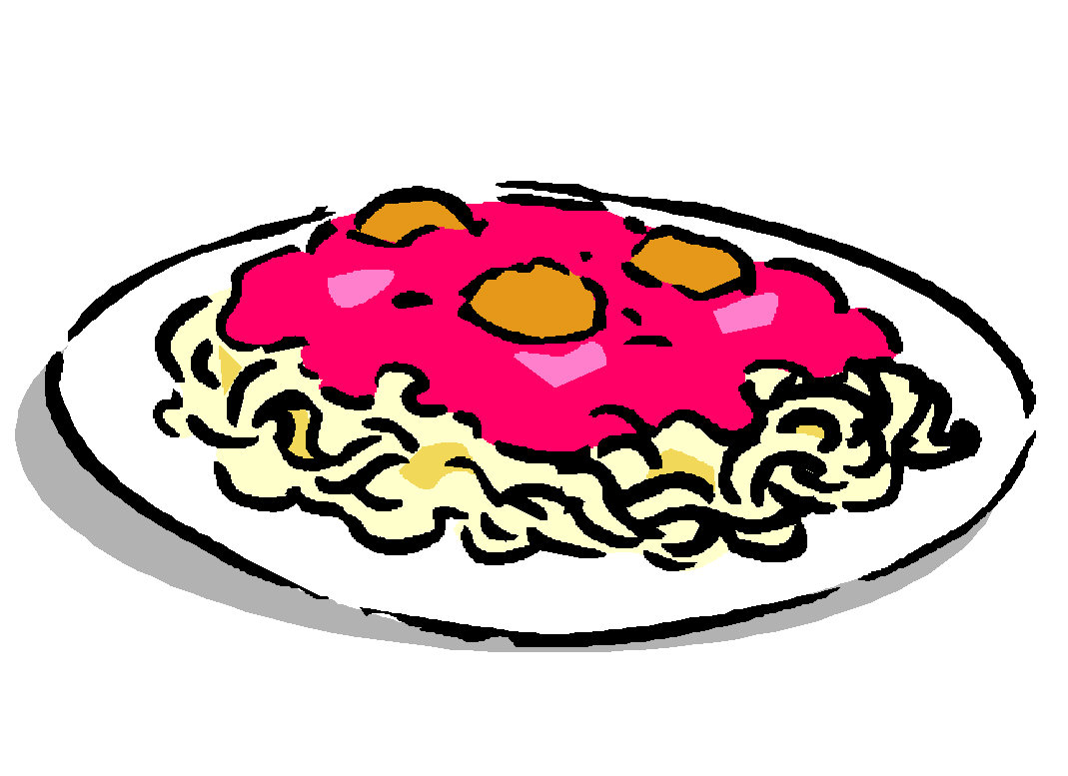  2. food stalls：美食攤位 | 12. uniform：制服
3. giant：具大的 | 13. Tonghwa night market：通化街夜市
4. food hall：美食街 | 14. Liaoning night market：遼寧街夜市
5. oyster omelets：蚵仔煎 | 15. Jaoho night market：饒河街夜市
6. coffin bread：棺材板 | 16. Liuhe night markets：六合夜市
7. jewelry：珠寶 | 17. Hsinhsing night markets：南華路新興夜市
8. furniture：家具 | 18. Chunghua night market：中華夜市
9. novelty items：小玩意 | 19. Hsiaopei night markets：小北夜市
10. traditional products：傳統物品 |   20. Chungwo Cheng night markets：中國城夜市
 | 21. Hsiao chi：小吃

Discussion

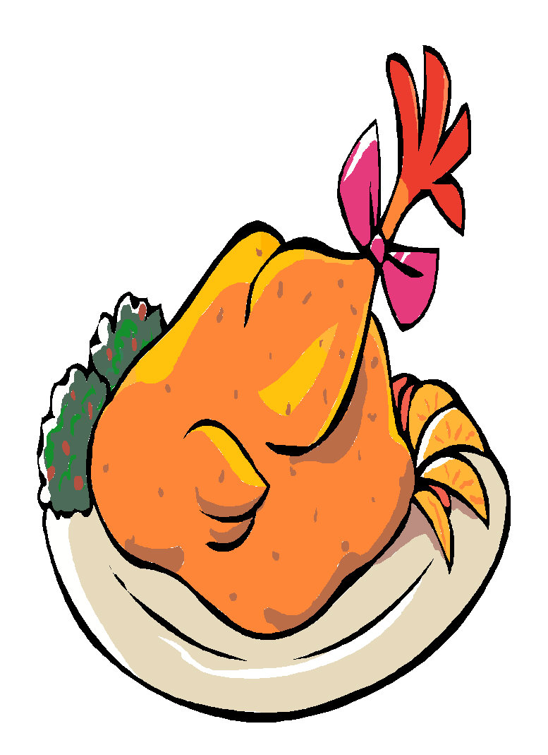

Discuss the following questions：
1. Do you go to night markets?

2. Which night market do you usually go to, and how often?

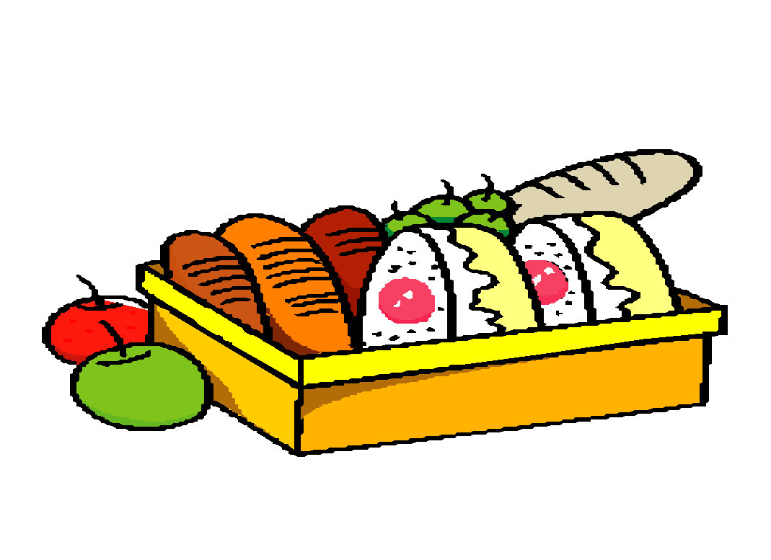
3. What do you usually do or buy there?

4. Who do you often go with?

5. What special meals or snacks can people buy at your local night market(s)?

6. Why do you think night markets are so popular in Taiwan?

Grammar
Some words for describing food

“It is too .” or “It is not enough.”

sweet 甜的 spicy/hot 辣的 bitter 苦的
salty 鹹的 sour 酸的 bland沒味道

To describe food you can also say…
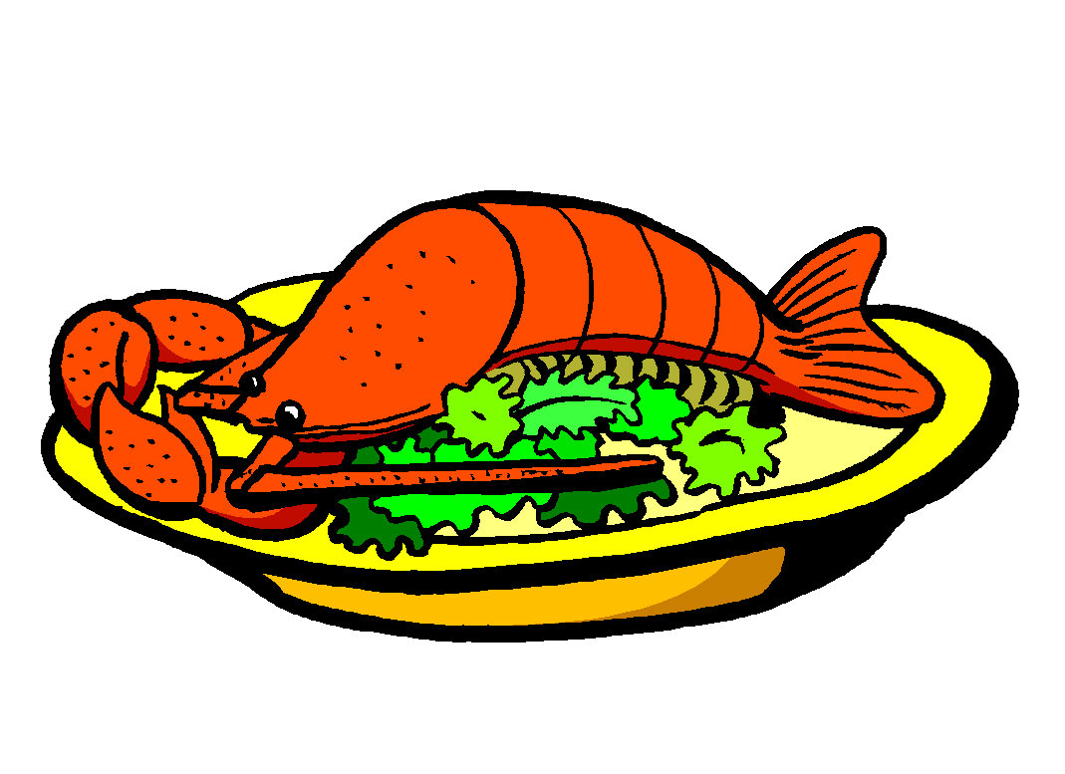
1. “It tastes nice”
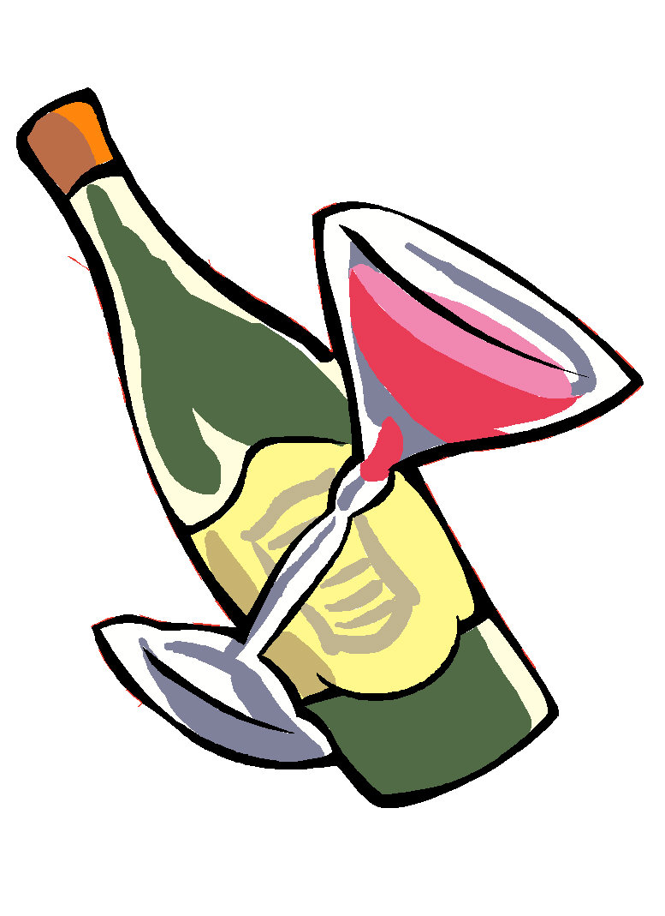
2. “It smells/ looks good”
3. “It tastes/ smells/ looks terrible”
4. “It doesn’t taste/ smell/ look so good”
5. “It’s too tough/ It’s not tender enough”
6. “It’s too oily/ fatty/ dry”

Table Etiquette

Cultural information you can tell guests from another country

Tell you guests that Taiwanese people consider…
1. impolite to leave their chopsticks standing vertically in food because they resemble sticks of incense being burned after someone has died.


2. impolite to use a toothpick to clean your teeth without covering your mouth.

3. impolite to leave partially chewed food (fat, etc) on the side

of your plate. People often put it in a tissue on the table.

Activity

Discuss with your classmates
Discuss the questions below with your classmates. Ask them the following questions, and finish it.

Name | Favorite night market | Location | Most favorite food | Special meal/ food
EX：  Peter | Hsiaopei night market（小北夜市） | Tainan（台南） | oyster omelets（蚵仔煎） | oyster omelets（蚵仔煎）；coffin bread（棺材板）

Homework

A night market (or your favorite night market) in Taiwan which you would like to recommend to your friends！
The information of the night market…
Name of the Night Market：
Location：
Special Food：
The Photo of the Night Market：

Simple Map of the Night Market：

My Favorite Food at the Night Market：(photos)

